|  |
| --- |
| Koohii Onegai |
| Byelingual |
| Design Document |

|  |
| --- |
| Sontra  2-11-2018 |

Contents

Description2

List of art assets2

Setting3

Characters4

Father4

Young woman5

Hitman6

Identity thief7

Other player identities8

Backgrounds and Items9

Bedroom9

Tea garden11

Kitchen13

Tea house16

Character sprites20

Father20

Young woman20

Hitman21

Resources23

| story 2  Yojijukugo  a play in four characters  **Story** by: Sontra Samela  **Art** by: Samuli Harjunen  **Language**: Japanese  **Description**: A comedy of manners and mistaken identity. The player choices contribute to establishing the player’s identity, which is both hidden and unknown in the beginning. There are four possible player identities. The story is branched based on which identity and identity subset is achieved. Act 2 involves a tea ceremony, success in which depends on knowledge and application of correct etiquette. If the player is unsuccessful at branching away from the default storyline trajectory, they will wind up being *the Identity thief* who meets an untimely end.  list of art assets  **Characters** (3): The Father, The Young woman, The Hitman  **Backgrounds** (4): Bedroom, Tea garden, Kitchen, Tea house interior  **Interactable** **items** (8): Cellphone, Lyrics, Flower, Postcard, Brochure, Poison, Hanging scroll, Ikebana  **Close**-**ups** **of** **items** (3): Lyrics, Postcard, Brochure  Setting  Location: Somewhere in the mountains of Nagano Prefecture, Japan  Era: Present day  Time of year: May  Weather: Sunny  Buildings: Old-fashioned, wooden, large; old, but well-kept  Infrastructure: All modern amenities, but use of electricity minimal      Figure : Edo-period buildings in Narai-juku, Nagano Prefecture |
| --- |

characters

The Father – a.k.a. Father-in-law / Landlord / Head of the family estate

Proud and conservative man with an unreadable, stony expression on his face. Late middle age, maybe 65 years old. Practitioner of the three classical arts of refinement: tea ceremony, incense appreciation, and flower arrangement. Enjoys sitting on a tatami floor contemplating Zen-principles and refuses to believe that the world is moving on. Has one daughter from a dissolved marriage. True to his conservative views, he had counted on a slew of (male) offspring to ensure the upkeep of the large family estate, which he inherited from his own parents. Unluckily, the woman he married was not so old-fashioned as to not believe in divorce. She still loves him, but she prefers to do it from a long distance. In the absence of devoted sons to maintain the estate, his finances are now coming to an end. As a desperate and naïve-to-the-ways-of-the-world man, it was easy for a couple of conmen to swindle him out of a mortgage or two against the manor and its grounds. In his deepened desperation, he has turned to another character of the underworld: an assistant in feigned deaths. Or is it that his indebtedness has made him prey to a real assassination plan? His daughter speaks of a young bachelor she wants him to meet, but it seems too little too late. He will face his fate head-on, but not before one last tea ceremony performed with pride.

The Young woman – a.k.a. Fiancée / Landlord’s daughter / Heiress

Photography student with a bright smile and a can-do attitude. Likes to stand with one hand on her hip, swaying on the balls of her feet, while talking to people. Other times her gaze wanders while looking around for interesting angles. Studying for her master’s, she is around 25 years old. In her childhood she was spoilt to bits by family in both her parents’ sides, but her exuberance of spirit was tempered by a willingness to soak in her father’s aesthetic of orderliness and disciplined grace. Many of her father’s dearest hobbies became lifelong interests of hers. However, it was not a relationship that involved the sharing of personal matters. Even now, she has no clue about the dire straits her father is in. She wants him to meet her boyfriend of 1,5 years and fiancé of one month (damn that engagement ring is shiny, but she dares wear it only to uptown café visits with her friends and romantic candlelit dinners with her fiancé, although sometimes he picks the wrong kind of a restaurant, and then she has to take the ring and her pearls off, blushing in embarrassment of being overdressed), but it has been difficult to think of a situation in which the two could be introduced to one another comfortably. A formal *chaji* tea ceremony is not what she had in mind at all, especially considering how her fiancé has never been in touch with that world before, but her father was oddly insistent on it being his way of welcoming her, and whoever was with her, home from Tokyo. Should she bring him along, or leave it for another time?

The Hitman – a.k.a. Tenant / and, alternatively, Feigned-death specialist

A tactful and cultured middle-aged man, the Hitman lives on the manor grounds under the presumed profession of a neurosurgeon. Having long since established himself with his landlord, he has no fear of intruding questions or snooping visitors. And he is well aware of his host’s naivety and seclusion from society. The man is an easy target. It doesn’t, however, make it any easier to accept the contract. This is both their home, and that daughter of the landlord’s is a lovely creature one couldn’t bear to see saddened. No, he certainly doesn’t wish for this. But if his landlord has lost his fortune, how long would the place even remain his home, before ownership changes and sends him the eviction notice? This living arrangement seems to have come to its end no matter what, even though the landlord keeps buying time by borrowing money from here and there. In fact, that is what he suspects is behind this recent invitation to attend a formal tea ceremony. It is no secret that his tenant makes a lot of money through his work and drives around in expensive cars. It has probably crossed the old man’s mind to request some future rental payments in advance. Maybe he should bring the money in cash with him to the fated tea ceremony, just to let the old bugger die happy?

// alternatively, the Hitman is not a hitman, but a feigned-death specialist, who has offered to deliver his landlord out of his woeful existence by giving him a new life with a new identity.

The Identity thief – a.k.a. Fake hitman / Fake tenant

Note: The Identity thief is a stand-in for the Hitman. He has a place in the story **only if** the player is him or the Hitman. If the player is the Hitman, the Hitman’s sprite represents the Identity thief. Who is who cannot be predicted until the player has reached Act 3, and therefore the two characters must look the same (at least from the player’s point of view).

Lifted almost entirely from the film The Key of Life (鍵泥棒のメソッド), the Identity thief is a failed actor, who has stubbornly kept trying the same thing despite crumbling relationships and his theatre company going bankrupt. As proof of his utter failure, he fails to succeed in any of his suicide attempts. One day he took a trip to his local bathhouse and chanced upon the incident of a customer slipping on a soap, falling on his head and dropping his locker key, which slid all the way to the Identity thief’s feet. While everyone else swarmed around the luckless customer, the Identity thief quietly swapped keys, having seen the expensive attire this customer came in wearing. With the intent to merely empty the guy’s wallet, his curiosity got the best of him as he discovered the car key, and eventually, the house key. His ambition perking up, he decided to inquire after the injured man. The hospital informed him that there was a persistent case of retrograde amnesia connected to the patient’s head trauma. The hospital assumes that the man’s identity is as stated in the ID card found in his

bathhouse locker. Realizing the opportunity to leave his old life behind, the Identity thief calls forth his questionable acting skills to assume another person’s identity. But what exactly is this person’s profession? Surely it cannot be a neurosurgeon, with all these disguises and lethal weapons in his house! If this person is a contract killer… is that the life he wants for himself? Is it even a role he could pull off?

Other player identities (never on screen)

The Suitor – a.k.a. Fiancé

Has more enthusiasm than grace. Is probably a *gaijin*, since they are unafraid to blurt out “I love you” in broad daylight. Is likely to interpret the presence of the Hitman as a rival suitor favoured by their prospective Father-in-law. Maybe Father-in-law is trying to rub it in their face that they are a newb *gaijin* who knows nothing?! But when Father-in-law dies mysteriously after the tea ceremony, it becomes evident that there is more to this mysterious tea guest.

The Real Estate agent

Mostly an outsider to bring contrasting options to player choices. Invited by the Father to gain an appreciation of the manor on sale.

Backgrounds and Items

**Act 1**: Early morning, maybe 7 am. The player starts the game in the Bedroom. They can switch (“move”) between three environments: Bedroom, Tea Garden, Kitchen. *Young woman* is in the Tea Garden. *Hitman* makes an appearance in the Kitchen.

**Act 2**: Morning to noon. Tea ceremony in the Tea house. *Father*, *Young woman* and *Hitman* are present. Player cannot move.

**Act 3**: Evening. The ending unfolds in the Bedroom, where the player may be visited by an NPC. Bedroom items are now uninteractable.

Bedroom **background** **image** (2 variations)

The player character’s bedroom for the night. Or maybe this is the bedroom of their home, or the bedroom of someone whose home they are occupying. Nevertheless, it will look the same regardless of who the player is. Part of the manor, it has similar wooden structures as the other rooms. Departing from tradition, there are some western furnishings: bed, bedside tables, ceiling light – maybe desk and chairs. The style is minimal and impersonal.

**Variation** 1: Early morning, lit by indirect sunlight through a window.  
**Variation** 2: Evening, dimly lit by a hanging ceiling light.

Bedroom **perspective**

The perspective must be such that it makes sense for the player to be standing where they are standing when an NPC enters the room in Act 3. In other words, the door must not be behind the player. The door does not have to be visible, but there must be a spot where an NPC can stand and face the player without needing to teleport to that location. Other than that, the perspective can be anything.

Bedroom **items** (2): Cellphone, Lyrics

Cellphone (2 variations)

A contemporary cellphone, lying face up in a visible location. Uninteractable at first, it will become interactable if the player re-enters the bedroom during Act 1, upon which it will start ringing. Perhaps it will be given a slight shaking animation for when it rings? To be decided later.

**Variation** 1: Inactive. The screen is unlit.  
**Variation** 2: Active: it is ringing. The screen is lit.

Lyrics (no variation) (close-up)

A slightly crumbled piece of white paper, this item may be less noticeable to the player at first. At least, it does not need to draw the eye the way the cellphone does. It is on a chest of drawers, a desk or a

bedside table. Clicking on the item leads to a close-up.

Close-up: If the paper was crumbled at first, it is now straightened enough for its writing to be legible. It turns out to be an A4-print of some lyrics, printed in portrait orientation. The lyrics themselves are added in the process of creating the associated puzzle, so the *game* *art asset* is blank.

Tea garden (露地) **background** **image** (no variation)

A moss-dominated, lushly green garden that follows the *wabi-sabi* aesthetic principles: simplicity, austerity, asymmetry and naturalness. The image should have at least two features that mark it as a tea garden: a path laden with stepping stones, and either the tea house itself, or a gate leading to the tea house. However, it need not be filled with tea cult paraphernalia. The Tea garden is a tranquil place for the player, as it is the only environment with no threatening interactions, so the background image would do well to reflect that. Keeping clutter to a minimum and highlighting the beauty of nature is the way to go.

Tea garden (露地) **perspective**

Not to make it look like either the player or the Young woman is coming from the tea house, there should probably be some distance

between it and the player perspective. The young woman is standing somewhere in the garden, facing the player and expecting them to come talk to her (= click on her). She is close enough to the interactable flower to overhear whatever the player chooses to soliloquy about the flower.

Tea garden (露地) **items** (1): Flower

Flower (no variation)

The freshly bloomed flower of a tree or a bush that blossoms in May in Nagano Prefecture. To be decided what exactly. The item may be disproportionately large compared to its surroundings in order to make it clearer to the player what it is. Upon clicking it, the player character will either recite a poem related to it or reminisce about the circumstances they were in last year at the time of the species’ bloom.

Kitchen (台所) **background** **image** (no variation)

A mix of old and new, this area is not the most glamorous of the manor. In fact, the player is not supposed to be there. It is a little uninviting to the untrained eye: all the surfaces are dark, light is suffused through milky windows, and there is clutter everywhere, although closer inspection shows that it is organized clutter.

Kitchen (台所) **perspective**

The atmosphere is intimate and especially in the event of the Hitman’s appearance, a little claustrophobic. This can be achieved by restricting the perspective to one part of the kitchen, instead of showing the whole room. A closer perspective will also make it easier for the player to click on the interactable items.

The game allows for a limited number of player interactions before it progresses from Act 1 to Act 2. The Hitman will not be in the kitchen initially, but he will enter it (sliding animation from left or right) after the player has completed one interaction in the room. This will not force dialogue. Maybe he is just following the player around, uninterested in speaking to them? Nevertheless, the player can initiate dialogue by clicking on the Hitman.

Kitchen (台所) **items** (3): Postcard, Brochure, Poison

Postcard (葉書) (no variation) (close-up)

Japanese-style postcard with vertical writing space. The address and stamp are on the reverse side, so they are not shown. It is sticking out of clutter somewhere in the room, but relatively easy to distinguish as a piece of paper for its white colour amidst all the dark shades.

Close-up: The player can read the contents of the card. Those

contents will be added in as a puzzle, so the *game art asset* should be blank, apart from a simple nature-themed watermark image decorating a corner or two. For example:

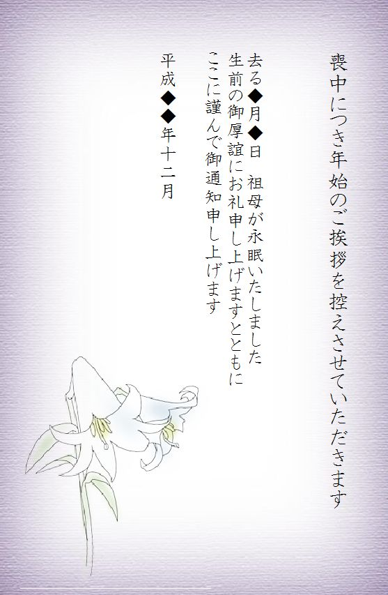

Figure 2: Japanese-style postcard

Brochure (パンフレット) (no variation) (close-up)

Unlike the postcard, which merrily adds to the chaos, the dignified brochure is lying neatly on a countertop. It catches the player’s eye by being lighter and more colourful than its surroundings, but it’s too far from the player for its lettering to be legible. The player cannot see what it is about until they click for the close-up.

Close-up: This is a brochure about tea ceremony which will give the player a hint about surviving Act 2 with honour. To be done later. The close-up is a low-priority item not included in Sprint 1 or Sprint 2 Backlog. The item will be uninteractable until development of the close-up.

Poison (no variation)

Actually, this item is not poison. Sorry about the confusion. The *interaction* is called “poison”, so the name stuck. The item is a group of small plates of *wagashi* (和菓子), confections such as *mochi*, sitting on a kitchen counter. These will be offered as part of the tea ceremony. When the player clicks on this item, a two-way choice will be presented to them: “Use poison” or “Do not use poison”. What exactly the consequences of the choice are is not revealed to the player immediately.

Example of *wagashi* (和菓子):

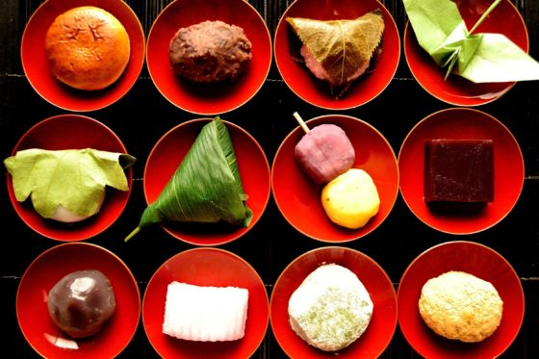

Figure : Confections on small serving plates

Tea house (茶室) **background** **image** (2 variations)

The tea house sequence is the climax of action in the storyline. Having said that, there is not much *action* there. Everyone is sitting on the floor in the *seiza* (星座) position, except for the tea master who is putting more weight on his knees, leaning forward, to fiddle with his tea utensils. The style of the tea house is very traditional *sukiya* (数寄屋) style, and there are no modern touches whatsoever. Since it is spring, the sunken hearth is covered, and a portable brazier (風炉)

is used to heat the cast iron tea kettle. In the *tokonoma* (床の間) alcove there is a seasonal flower arrangement and a hanging scroll. For the sake of austere simplicity, there are no other decorations. The space is lit by daylight coming in through small *shōji* (障子) windows.

**Variation** 1: Guests have received nothing yet, host is pouring water.  
**Variation** 2: Guests have trays with big tea bowls, *chawan* (茶碗), and small plates of *wagashi* on the floor in front of them, host is watching them while sitting upright in the *seiza* position.

Tea house (茶室) **perspective**

Sitting upright, eyes ahead, the player probably cannot see the tray in front of them. When the player sees the trays in front of the other two guests (Tea house variation 2), they will just have to surmise that they have a tray in front of them, too. The player should be the guest of honour, i.e. the guest with the best view of the *tokonoma* alcove. Having direct line of sight to the hanging scroll, the player should be able to make out is writing without there being a close-up version of the scroll.

Example sitting arrangement for one host and three guests in the image below. In this case, the player would be the rightmost figure, the Young woman the figure in the middle, and the Hitman the leftmost figure. I think.

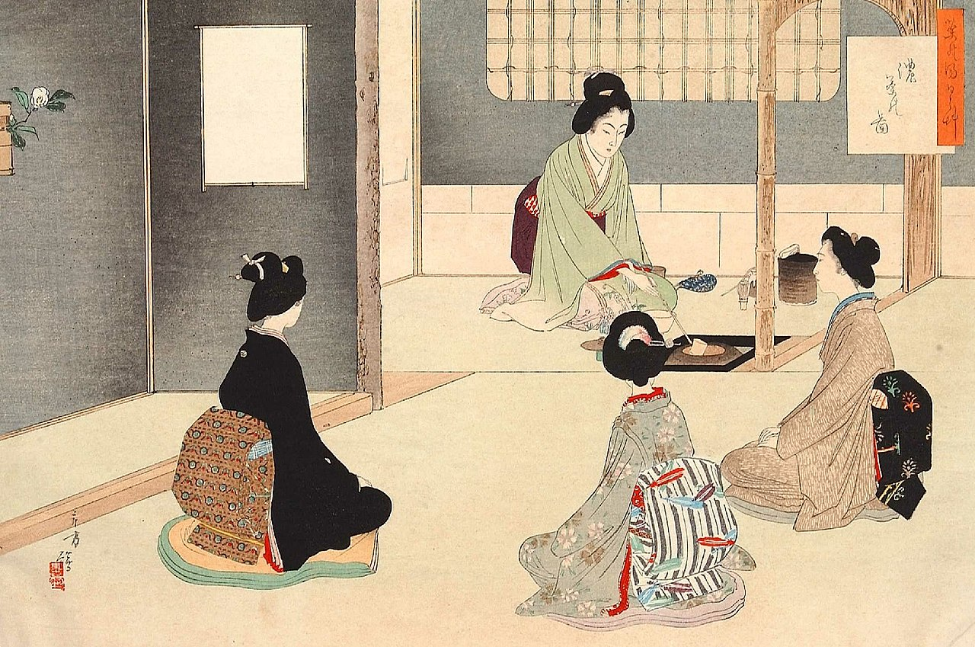

Figure : Tea room with a tokonoma on the left (with a sunken hearth, not brazier)

Tea house (茶室) **items** (2): Hanging scroll, Ikebana

Hanging scroll (掛け軸) (no variation)

Hangs in the middle of the *tokonoma* alcove wall. Has the classic tea ceremony phrase written on it in calligraphy: 一期一会 (ichi-go ichi-e).

When the player clicks on it, a choice to make a comment about it is presented.

Ikebana (生け花) (no variation)

A seasonal flower arrangement on the *tokonoma* alcove floor. To be decided what exactly. When the player clicks on it, a choice to make a comment about it is presented.

Character Sprites

All of the following characters are native Japanese.

The Father (3 variations) – appears in Act 2

He wears a plain *kimono*.

**Variation** 1: Sitting by the brazier, leaning over to pour water.

**Variation** 2: Sitting *seiza*, chin up, looking at no-one in particular.

**Variation** 3: As above, but with jaw dropped, frowning, looking at the player, disturbed by the player’s sudden outburst (about double suicide, if he does not bless the suitor’s engagement to his daughter).

The Young woman (5 variations) (2 recolours) – appears in Act 1, 2 and 3

**Variation** 1: Standing with one hand on her hip, facing the player, smiling wide with an open mouth, her eyes narrowed by the smile. Wears casual western clothes. She could be carrying a camera, but then the camera would need to be removed in the recolour. This is in the Tea garden in Act 1.

**Variation** 2: As above, but the hand has dropped from her hip, her smile is still warm, but the mouth is closed, and her eyebrows are raised as a sign of strong engagement in dialogue with the player.

**Variation** 3: Sitting *seiza* on a *tatami* floor, with her hands in her lap, she is looking at her father. Wears a plain *kimono*. This is in the Tea house in Act 2.

**Variation** 4: As above, but she is looking at the player instead.

**Variation** 5: Part of an unhappy ending, she is standing with a hunched back, hands covering her pained face as she weeps. She is back to wearing the western clothes she wore in the morning. This is in the Bedroom (variation 2) in the evening in Act 3.

**Recolour** 1: Recolour of sprite variation 1 to match the dim light of the Bedroom in the evening. Part of a happy ending. This is for Bedroom (variation 2) in Act 3.

**Recolour** 2: Recolour of sprite variation 2 to match the dim light of the Bedroom in the evening. Part of a happy ending. This is for Bedroom (variation 2) in Act 3.

The Hitman (5 variations, 2 recolours) – appears in Act 1, 2 and 3

**Variation** 1: Stands looking at the player impassively, his mouth a straight line. Wears dark, semiformal western clothes, so that he is almost camouflaged by the dark kitchen. This is in the Kitchen in Act 1.

**Variation** 2: As above, but his mouth is slightly ajar, and his eyebrows

slightly raised, perhaps in a mocking gesture.

**Variation** 3: Sitting *seiza* on a *tatami* floor, he is out of the limelight in this situation. He keeps his impassive gaze hyper politely on the floor. Wears an expensive looking, dark *kimono*. This is in the Tea house in Act 2.

**Variation** 4: As above, but his gaze has risen to regard the player.

**Variation** 5: Part of an unhappy ending, the Hitman stands in the Bedroom, frowning, growling, looking tense and irritated. He has a few choice words to say, gruffly, but has most of his composure intact. He is back to wearing western clothes. This is in the Bedroom in the evening in Act 3.

**Recolour** 1: Recolour of sprite variation 1 to match the dim light of the Bedroom in the evening. Part of a happy ending. This is for Bedroom (variation 2) in Act 3.

**Recolour** 2: Recolour of sprite variation 2 to match the dim light of the Bedroom in the evening. Part of a happy ending. This is for Bedroom (variation 2) in Act 3.

Resources

Architectural style <https://en.wikipedia.org/wiki/Sukiya-zukuri>

Film influence <https://en.wikipedia.org/wiki/Key_of_Life>

Hanging scroll <https://en.wikipedia.org/wiki/Ichi-go_ichi-e>

Tea ceremony <https://en.wikipedia.org/wiki/Tea_ceremony>

Tea ceremony seasons <http://japanese-tea-ceremony.net/types_ceremony.html>

Tea garden <https://en.wikipedia.org/wiki/Roji>

Tea house <https://en.wikipedia.org/wiki/Chashitsu>